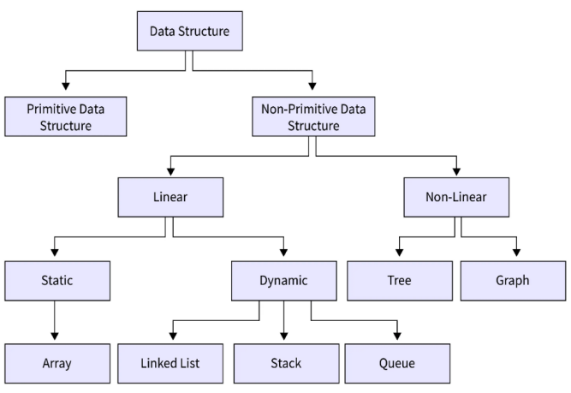Remember – If Any data structure is implemented using Array then it will be always Static.
Prepared By - Mr. Vismay Shah 1
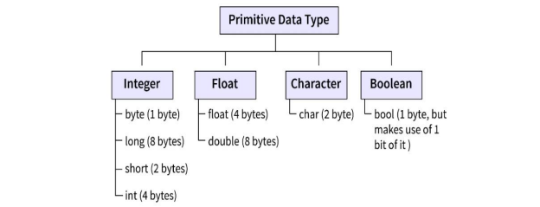
While calculating the Address in 1-D array or 2-D array, if the size of single element is not given and type of array is given then recall these sizes. (for example – in a numerical type of array is given as double then we must take size of single element = 8 bytes)
Prepared By - Mr. Vismay Shah 2
Size of Array
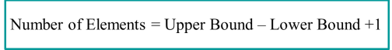
Upper Bound = Index of Last Element of Array
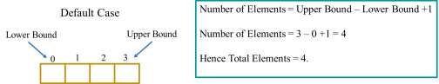
Lower Bound = Index of First Element of Array The same concept
for with
2D array.
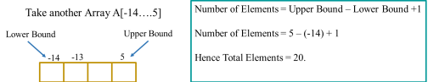
Prepared By - Mr. Vismay Shah 3
Address Calculation of One-Dimensional Array LOC(A[i])= Base Address of A + (i-LB) * Size of Single Element
Where i is the Index at which you need to find the address and LB is the lower bound value of the Array.
Prepared By - Mr. Vismay Shah 4
Address Calculation of Two-Dimensional Array
In 2-D array, the data gets stored in 2 ways.
Row Major Order (RMO)
Column Major Order (CMO)
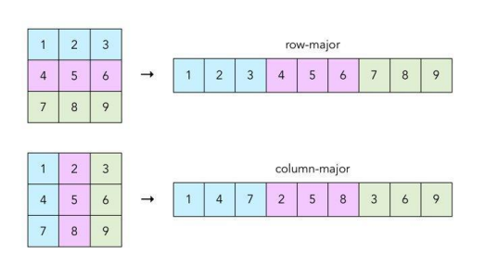Prepared By - Mr. Vismay Shah 5
When Data Stored in RMO
������������ ���� �� �� �� = �� + �� ∗ �� − ���� ∗ �� + �� − ����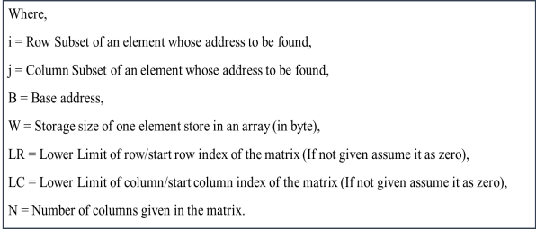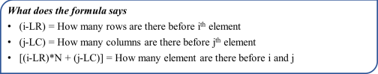Prepared By - Mr. Vismay Shah 6
When Data Stored in CMO
������������ ���� �� �� �� = �� + �� ∗ i − ���� + j − ���� ∗ M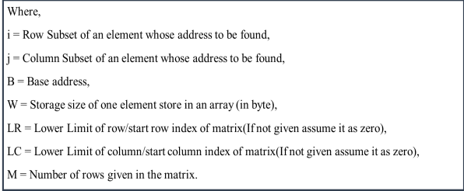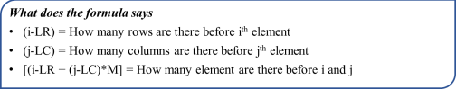Prepared By - Mr. Vismay Shah 7
Address of k^{th} Element in 1-D Array
Let us take an example to understand this concept –
Consider an Array A[-12…..25] and we want to find the address of the 19th element.
In such situation use the below mentioned formula to find the index for the asked element.
���������� [��] = �� + �� − 1
L is value of Lower bound (which is -12 in our case)
K is the element for which we are asked (which is 19 in our case)
Hence, index of 19th element will be = -12 + 19 – 1 = 6 ������ ������ ��ℎ�� �������������� ������ 1 − �� ��������������
Prepared By - Mr. Vismay Shah 8
Address of k^{th} Element in 1-D Array
Let us take an example to understand this concept –
Consider an Array A[-12…..25] and we want to find the address of the 19th element.
In such situation use the below mentioned formula to find the index for the asked element.
���������� [��] = �� + �� − 1
L is value of Lower bound (which is -12 in our case)
K is the element for which we are asked (which is 19 in our case)
Hence, index of 19th element will be = -12 + 19 – 1 = 6 ������ ������ ��ℎ�� �������������� ������ 1 − �� ��������������
Prepared By - Mr. Vismay Shah 9
Address of k^{th} Element in 2-D Array
Let us take an example to understand this concept –
Consider an Array P[-4…3][2…13] and we want to find the address of the 25th element.
In such situation,
First Check for CMO or RMO.
If CMO – then take L = Lower Bound of Row
If RMO – then take L= Lower Bound of Column
���������� [��] = �� + �� − 1
������ ������ ��ℎ�� �������������� ������ 1 − �� ��������������
Prepared By - Mr. Vismay Shah 10

